Российское Общество Изучения Канады (РОИК)
Russian Association for Canadian Studies (RACS)
L’Association Russe des Etudes Canadiennes (AREC)
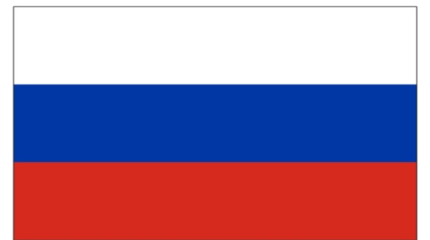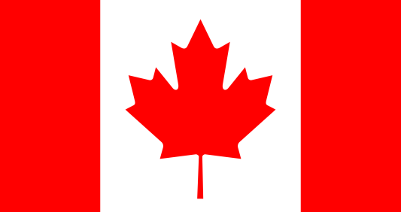
International Council for Canadian Studies member
Российская Федерация  109004, Mосква  Тетеринский переулок 12 с. 5  Телефон: (495) 915-3227 (#304)  Эл.почта: racsoffice@mail.ru | 12 bld.5 Teterinsky Pereulok  109004, Moscow  Russian Federation  Tel.: (495) 915-3227 (#304)  E-mail: racsoffice@mail.ru | 12 c. 5 Teterinskyy pereulok  109004, Moscou  Federation Russe  Tel.: (495) 915-3227 (#304)  E-mail: racsoffice@mail.ru

CALL FOR PAPERS

The 18th RACS Annual International Conference

«Russia and Canada: Summing-up 2021»
Moscow
2021 December,9

RACS invites proposals for papers for the 18th Annual International Conference of the Russian Association for Canadian Studies. The Conference is open to scholars in any relevant discipline, and explicitly aims to promote interdisciplinary dialogue.

The first part of the Conference will be devoted economics, business and politics including Arctic issues, the appropriate themes include but are not limited to the following: policies of the countries towards each other at the current moment, and enhancing international cooperation in the North and Arctic.

The second part will allow the contribution from Canadianists in different areas covering the themes of domestic social policies and cultural developments. Any other theme relevant to Canadian Studies (Canadian history, literature, etc.) will be also considered.

Covid-19 pandemic measures and consequences are of a special interest as well.
The working languages are Russian, English and French. The Conference will take place in the capital of the Russian Federation – the City of Moscow. There is no registration fee for RACS members, its partners or affiliated organizations, national Associations for Canadian Studies and ICCS members. The Conference will take place both in online and offline formats.

We welcome proposals for papers in Russian, English or French, consisting of an abstract (maximum 300 words) and a short biography of the author and appropriate affiliation (maximum 300 words) to be submitted to the RACS-2021 Conference, Steering Committee, Moscow, Russian Federation by e-mail file in .doc or .rtf format –
racsoffice@mail.ru by December, 1 2021.

